Section 1: Case Summary

Scenario Title: | Intentional acetaminophen overdose
Keywords: | Toxicology, overdose, mental health emergency
Brief Description of Case: | A 25-year-old male is brought to the emergency department by EMS after a deliberate acetaminophen overdose. He presents with vomiting and abdominal pain. The patient refuses treatment, becomes angry, and tries to leave. He requires multiple efforts by MD to verbally de-escalate throughout the course of medical treatment.

Goals and Objectives
Educational Goal: | To allow learners to identify and treat acute acetaminophen toxicity in an uncooperative patient requiring involuntary admission
Objectives:  (Medical and CRM) | Medical  - Identify acetaminophen toxicity  - Initiate appropriate management for acetaminophen toxicity  - Identify the need for a patient’s involuntary admission  - Understand the components of the Mental Health Act for involuntary admission  CRM  - Mobilize resources to complete simultaneous investigation and treatment of an uncooperative patient.  - Anticipate and plan for a potentially hostile patient
EPAs Assessed:

Learners, Setting and Personnel
Target Learners: | ☒ Junior Learners |  | ☐ Senior Learners |  |  | ☐ Staff
 | ☐ Physicians | ☐ Nurses |  | ☐ RTs | ☐ Inter-professional
 | ☐ Other Learners:
Location: | ☒ Sim Lab |  | ☐ In Situ |  |  | ☐ Other:
Recommended Number of Facilitators: | Instructors: 1-2
 | Sim Actors: 1
 | Sim Techs: 0

Scenario Development
Date of Development: | March 7, 2023
Scenario Developer(s): | Elaine Liu
Affiliations/Institutions(s): | University of British Columbia, Faculty of Medicine
Contact E-mail:
Last Revision Date:
Revised By:
Version Number: | 1

Section 2A: Initial Patient Information

- Patient Chart
Patient Name: Chris Castillo |  |  |  | Age: 25 | Gender: M | Weight: 83 kg
Presenting complaint: Vomiting and abdominal pain
Temp: 37.1 | HR: 76/min | BP: 126/76 |  | RR: 18 | O₂Sat: 98% | FiO₂: 21%
Cap glucose: 5.6 mmol/L |  |  |  | GCS: 15 (E 5 V 4 M 6)
Triage note: 25M with vomiting and abdominal pain was brought in by EMS. An empty bottle of Tylenol was found in the patient’s bedroom.
Allergies: NKDA
Past Medical History:  None |  |  | Current Medications:  None

Section 2B: Extra Patient Information

A. Further History
Include any relevant history not included in triage note above. What information will only be given to learners if they ask? Who will provide this information (mannequin’s voice, sim actors, SP, etc.)?

Chris was last seen acting normally 6 hours ago. His roommate found him vomiting with an empty bottle of Tylenol beside him before calling EMS. His roommate says the Tylenol bottle was half full (approximately 100 tabs of 500mg extra strength).

Chris denies consuming alcohol, marijuana, or other elicit substances today. He denies any other co-ingestions.

Confirms the ingestion was about 4 hours ago.

B. Physical Exam
List any pertinent positive and negative findings
Cardio: Normal S1 and S2. No murmurs or extra heart sounds. Palpable peripheral pulses x4 | Neuro: Normal
Resp: Breath sounds equal bilaterally, no adventitious sounds | Head & Neck: Unremarkable
Abdo: Soft, diffuse tenderness without guarding. | MSK/skin: Normal
Other: Mildly uncooperative to questioning and exam, appears irritated

Section 3: Technical Requirements/Room Vision

A. Patient
☐ Mannequin (specify type and whether infant/child/adult)
☒ Standardized Patient
☐ Task Trainer
☐ Hybrid
B. Special Equipment Required
Standard PPE
NIBP cuff / Pulse oximeter
Cardiac monitor
IV Bags/Lines

C. Required Medications
NAC IV

D. Moulage
Young adult male in street clothes.
E. Monitors at Case Onset
☐ Patient on monitor with vitals displayed
☒ Patient not yet on monitor
F. Patient Reactions and Exam
Include any relevant physical exam findings that require mannequin programming or cues from patient
(e.g. – abnormal breath sounds, moaning when RUQ palpated, etc.) May be helpful to frame in ABCDE format.

Moaning when abdomen deeply palpated, most prominently in RUQ.

A: Patient speaking. Complains of mild, diffuse abdominal pain.
B: No distress or increased work of breathing
C: Normal pulses, regular rate and rhythm.
D: GCS 15
E: Normal

Section 4: Sim Actor and Standardized Patients

Sim Actor and Standardized Patient Roles and Scripts
Role | Description of role, expected behavior, and key moments to intervene/prompt learners. Include any script required (including conveying patient information if patient is unable)
Patient (Standardized Patient) | Initially irritable, responds to questions with few words or short phrases like:  “Things are bad”  “I don’t want to be here anymore”  “No one will miss me”  “I just want to go home”  Resistant to all treatments and questions when first offered but can be convinced with further discussion. Mild agitation but never violent. Responds positively to the doctor but not the nurses.  When NAC treatment is attempted, patient says “I don’t want this, I don’t want to be here anymore” but allows nursing staff to continue with treatment after discussion.
Bedside RN | Skilled, professional. When patient is resistant to nursing tasks, RN will repeatedly ask MD to talk with patient

Section 5: Scenario Progression

Scenario States, Modifiers and Triggers
Patient State/Vitals | Patient Status | Learner Actions, Modifiers & Triggers to Move to Next State |  | Facilitator Notes
1. Baseline State  Rhythm: Sinus  HR: 76  BP: 128/86  RR: 18  O₂SAT: 98%  T: 37.1ºC  GCS: 15  Glucose: normal | Patient is alert, appears irritated, vague history, complains of abdominal pain, but soft on palpation. | Expected Learner Actions  Interview patient  Confirm quantity/time of ingestion  Ask about co-ingestions  Perform physical exam- focusing on toxidrome findings  Order ECG  Order bloodwork  Consider IV fluids | Modifiers  - Patient reluctant to give blood or start IV line, but ultimately agrees  Triggers  For progression to next state  - 5 min 2. Return of Investigations | Bloodwork to include acetaminophen serum levels
2. Return of Investigations  Vitals unchanged | Same as above  Labs available | Refer to modified Rumack-Matthew nomogram  Consider calling poison centre  Start NAC (IV or PO)  Persuade patient to accept NAC treatment | Modifiers  - Patient initially refuses NAC treatment  Triggers  - Discuss NAC treatment or at 5 min 3. Patient demands to leave
3. Patient demands to leave  HR: 90 | Patient becomes angry and demands to leave | Attempt to verbally de-escalate patient  Complete form for involuntary psychiatric hold and inform the patient  Start NAC IV | Modifiers  - Patient remains angry despite attempts to deescalate  - Patient threatens to pull IV out  Triggers  - Completing Form 4 4. Admission
4. Admission  Vitals unchanged | Patient remains angry and but allows treatment | Expected Learner Actions  Continue NAC protocol  Admit to internal medicine with psychiatric consult | END Scenario

Appendix A: Laboratory Results (SI units)

CBC  WBC 5.6  Hgb 140  Plt 267  Lytes  Na: 140  K: 4.1  Cl: 103  HCO₃: 30  AG: 10  Urea: 3.6  Cr: 78  Glucose: 4.5  Extended Lytes  Ca 2.33  Mg: 0.71  PO₄: 1.17  Albumin: 43  TSH: 2.6  VBG  pH: 7.38  pCO₂: 35  pO₂: 98  HCO₃: 28  Lactate: 0.3 | Cardiac/Coags  Trop: 0  INR: 1.0  aPTT: 27s  Biliary  AST: 42 (H)  ALT: 23  GGT: 12  ALP: 40  Bili: 15  Lipase: 28  Tox  EtOH: <2  ASA: 0  Tylenol: 567 ug/mL

Appendix B: ECGs, X-rays, Ultrasounds and Pictures

Paste in any auxiliary files required for running the session. Don’t forget to include their source so you can find them later!

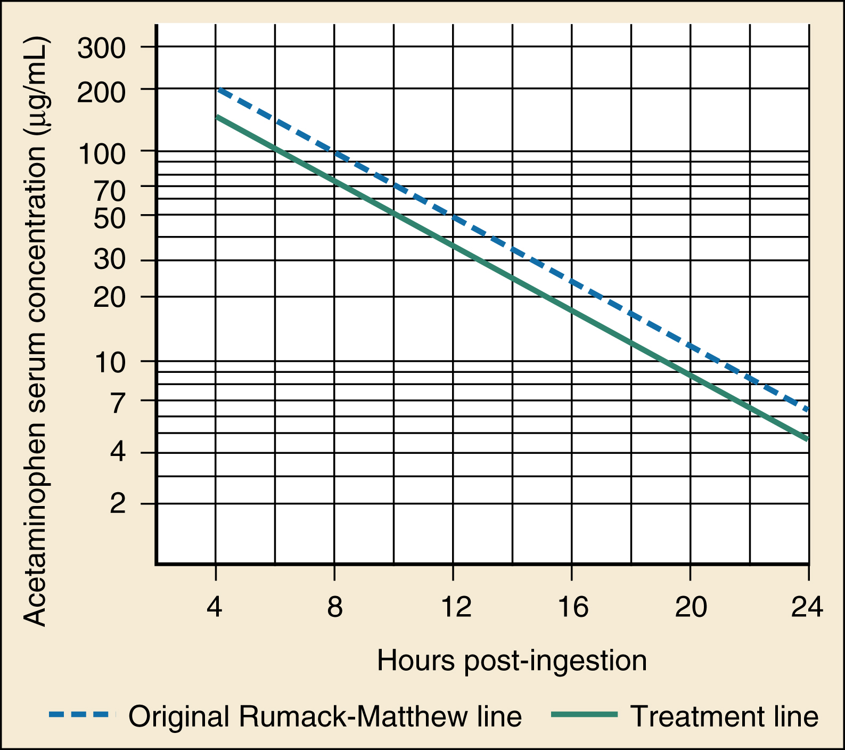
Nomogram source: Rosen’s Emergency Medicine

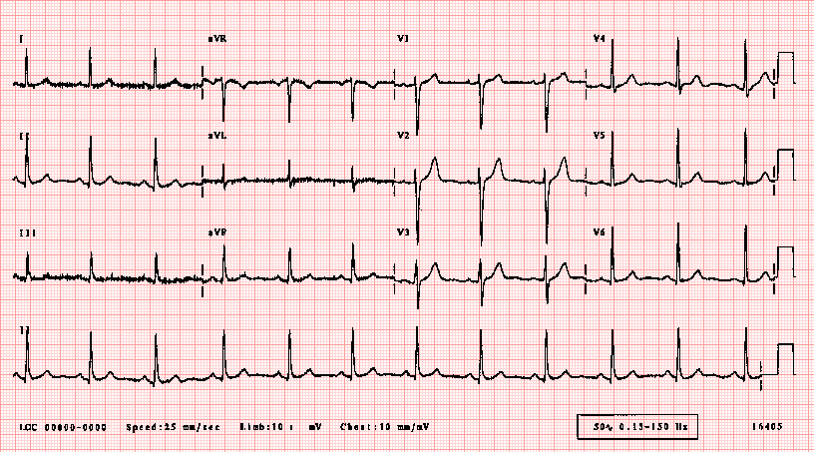
ECG source: https://ecglibrary.com/norm.php

Appendix C: Facilitator Cheat Sheet & Debriefing Tips

Debriefing in a group/Sample questions:

Crisis-Resource Management Questions:
- What are strategies that you can use to engage with an agitated patient?
- How did you approach this uncooperative patient?
- Describe ways that you handled this situation to ensure the safety of both the patient and your staff.

Medical Management Questions:
- What are the signs and symptoms of acetaminophen toxicity at different times post ingestion?
- <12 hours up to 24hrs (pre-injury): asymptomatic, nausea, vomiting, anorexia, malaise – elevated serum acetaminophen concentration
- 8 to 36 hours (liver injury): nausea, vomiting RUQ tenderness – rise in AST
- 2 to 4 days (maximum liver injury): liver failure, encephalopathy, coagulopathy, hemorrhage, acidosis – ARDS, sepsis/SIRS, multiorgan failure, cerebral edema
- >4 days (recovery): recovery, asymptomatic

- What are the indications for consulting Medical Toxicology for acetaminophen toxicity?
- Signs of hepatotoxicity at presentation (metabolic acidosis, hepatorenal syndrome, hepatic encephalopathy)
- Patients with preexisting liver disease
- Massive ingestion (serum acetaminophen concentration >900 µg/mL)

- What is the mechanism by which NAC helps treat acetaminophen toxicity?
- Acts as a glutathione precursor
- Acts as a glutathione substitute that reduces NAPQI back to APAP
- Increases sulfation metabolism of NAPQI
- Improves microcirculatory hepatic flow
- Acts as an antioxidant and free radical scavenger

- What are the indications for emergent hemodialysis following acute acetaminophen ingestion?
- Serum acetaminophen concentration >1000 µg/mL at 4hrs post ingestion
- Hepatorenal syndrome (Cr >3.5)
- Metabolic acidosis with pH <7.30
- Encephalopathy
- Elevated lactate (>3.5mmol/L)

References

1. Ganetsky M. Acetaminophen. In: Walls R et al., editors. Rosen's emergency medicine: Concepts and clinical practice. Philadelphia: Elsevier; 2023. p. 1861–6.
2. Agrawal S, Khazaeni B. Acetaminophen Toxicity. In: Statpearls [Internet]. Treasure Island, FL: StatPearls Publishing; 2022. Available from: https://www.ncbi.nlm.nih.gov/books/NBK441917/

